Fi-Ware Social Proximity App

Design Document

Joshua Eisikovits: C00156665

Project Supervisor: Dr Chris Meudec

17/04/2015

Table of Contents
Introduction 3
Context Diagram 3
System Architecture 4
Data Design 5
Data Description 6
Data Dictionary 6
User Profile Table 6
Event Organisers Table 7
Sports Event Table 8
Food and Drink Events Table 9
Music Events Table 10
Use Case Diagram 11
System Sequence Diagram 12
Login System Sequence Diagram 12
CRUD Profile System Sequence Diagram 13
Event Organiser Register System Sequence Diagram 14
Create Event System Sequence Diagram 15
References 16
Ref [1] 16

Introduction

Purpose

The purpose of the design document is to explain how the Fi-Ware Social Proximity App should work. The document is a continual of the functional specification which described what the app should be able to do, therefore this document looks at the functionality provided by the functional specification and describes in detail with the use of Unified Modelling Language Diagrams.
This document should act as a blueprint for any developer to go ahead and develop this application based on the provided information.

Scope
This document contains complete description of the design of the Fi-Ware Social Proximity App. The document aims to describe each component of the application. The document is intended for developers of the application. It defines the architecture, use cases, data design and user interface design. The application will be developed according to the contents of this document. However changes throughout the duration of the project may occur.

Context Diagram
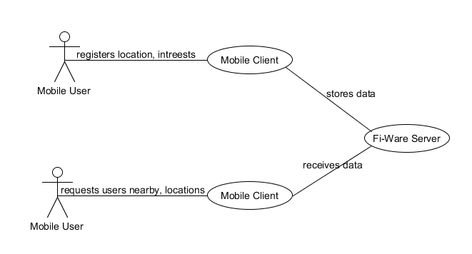

System Architecture

Ref [1]
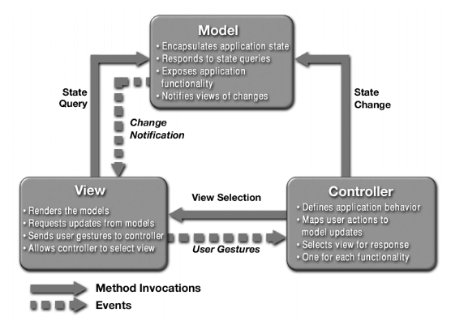
The Fi-Ware Social Proximity Application will be developed using the model-view-controller architectural design pattern, which is the pattern used for developing Android applications. The model is the data, the view is the window and the controller is the glue between the two taking the data and presenting it to the view. The diagram below illustrates the Model-View-Controller pattern.

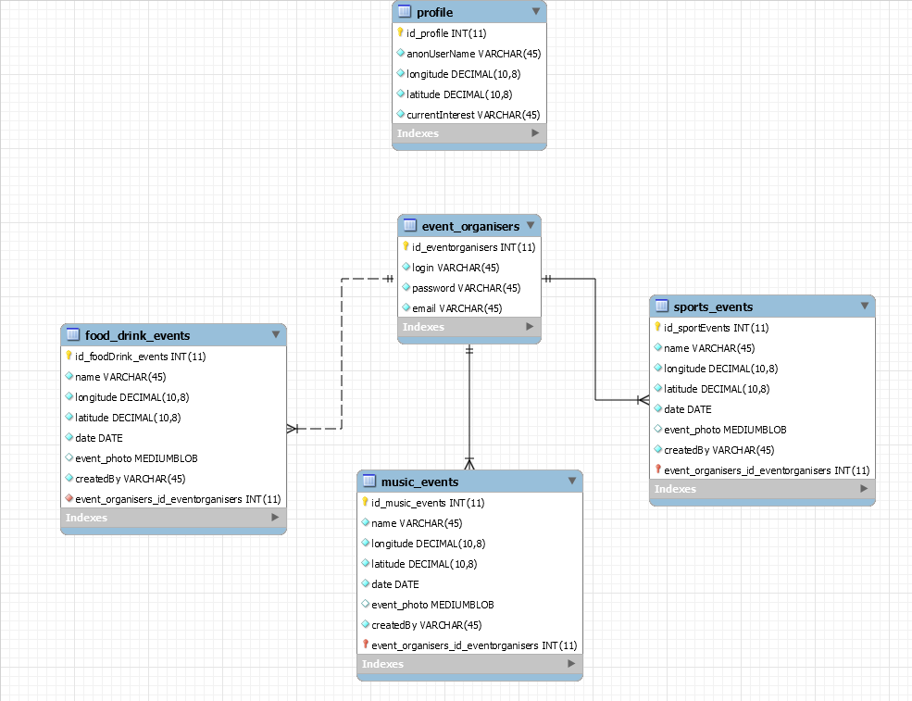
Data Design

Data Description
The Fi-Ware application data will consist of user profile data, event organisers’ data, sports, food and drink and music event data.
Data within the tables will be related to each other through the use of primary keys and relationships.

Data Dictionary
The above data design diagram can be clarified as follows.

User Profile Table

Column Name | Data Type | Description
id_user_profile | INT (Primary Key) | Auto generated integer value to hold user id.
anon_User_Name | VARCHAR(45) | Up to 45 alphanumeric characters for anonymous user name
longitude | DECIMAL(10,8) | Longitude coordinates for the position of the current user
latitude | DECIMAL(10,8) | Latitude coordinates for the position of the current user
current_Interest | VARCHAR(45) | Up to 45 alphanumeric characters for users current interest

Event Organisers Table

Column Name | Data Type | Description
id_eventorganisers | INT (Primary Key) | Auto generated integer value to hold event organisers id.
login | VARCHAR(45) | Up to 45 alphanumeric characters for anonymous login.
password | VARCHAR(45) | Up to 45 alphanumeric characters for password.
email | VARCHAR(45) | Up to 45 alphanumeric characters for event organisers email address.

Sports Event Table

Column Name | Data Type | Description
id_sportEvents | INT (Primary Key) | Auto generated integer value to hold event organisers id.
name | VARCHAR(45) | Up to 45 alphanumeric characters for sports event name.
longitude | DECIMAL(10,8) | Longitude coordinates for the position of the sport event.
latitude | DECIMAL(10,8) | Latitude coordinates for the position of the sport event.
date | DATE | The date of the sport event.
event_photo | MEDIUMBLOB | The logo of the sport event.
createdBy | VARCHAR(45) | Will be used to hold the (session) login id of the user who created the event
event_organiser_id_eventorganisers | INT | The relationship field between the sport event table and event organiser table.

Food and Drink Events Table

Column Name | Data Type | Description
id_foodDrink_events | INT (Primary Key) | Auto generated integer value to hold event organisers id.
name | VARCHAR(45) | Up to 45 alphanumeric characters for food/drink event name.
longitude | DECIMAL(10,8) | Longitude coordinates for the position of the food/drink event.
latitude | DECIMAL(10,8) | Latitude coordinates for the position of the food/drink event.
date | DATE | The date of the food/drink event.
event_photo | MEDIUMBLOB | The logo of the food/drink event.
createdBy | VARCHAR(45) | Will be used to hold the (session) login id of the user who created the event
event_organiser_id_eventorganisers | INT | The relationship field between the food/drink event table and event organiser table.

Music Events Table

Column Name | Data Type | Description
id_foodDrink_events | INT (Primary Key) | Auto generated integer value to hold event organisers id.
name | VARCHAR(45) | Up to 45 alphanumeric characters for food/drink event name.
longitude | DECIMAL(10,8) | Longitude coordinates for the position of the food/drink event.
latitude | DECIMAL(10,8) | Latitude coordinates for the position of the food/drink event.
date | DATE | The date of the food/drink event.
event_photo | MEDIUMBLOB | The logo of the food/drink event.
createdBy | VARCHAR(45) | Will be used to hold the (session) login id of the user who created the event
event_organiser_id_eventorganisers | INT | The relationship field between the food/drink event table and event organiser table.

Use Case Diagram
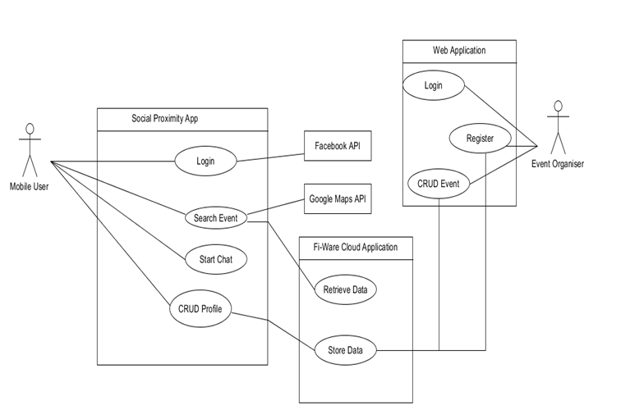

System Sequence Diagram

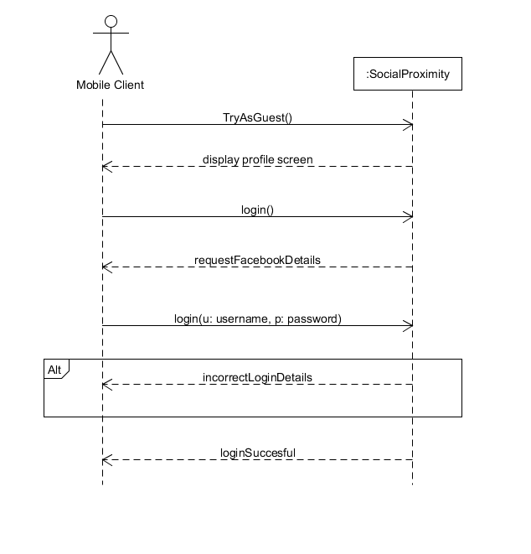
Login System Sequence Diagram

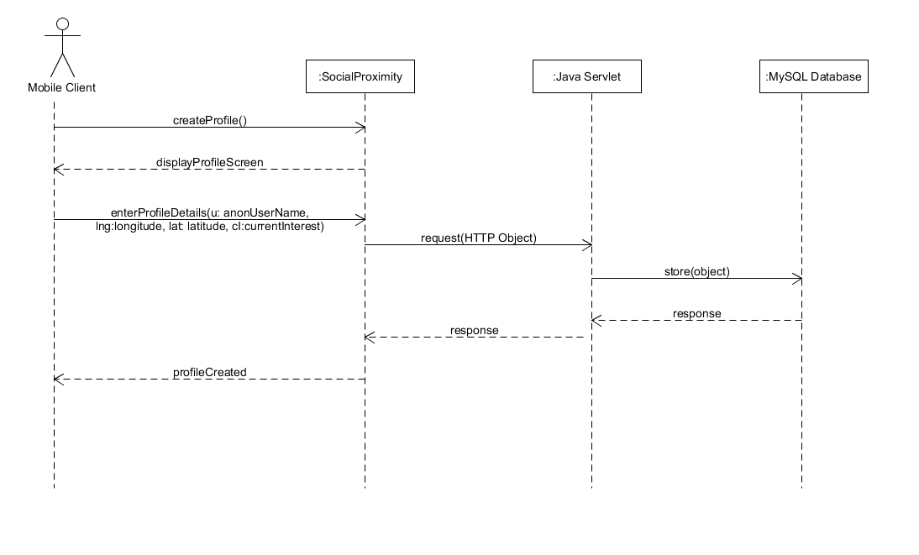
CRUD Profile System Sequence Diagram

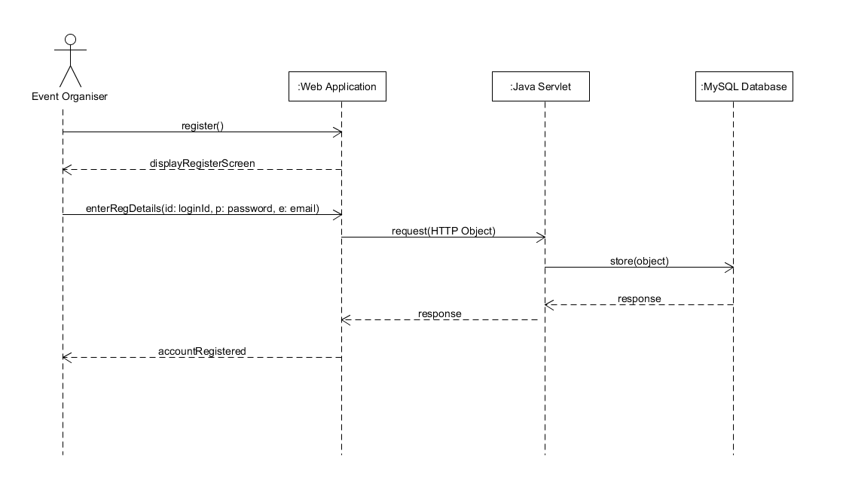

Event Organiser Register System Sequence Diagram

Create Event System Sequence Diagram

References

Ref [1]
Bogotobogo.com, 'Design Patterns: Model View Controller (MVC) Pattern - 2015'. N.P., 2015. Web. 11 Apr. 2015.

